Median Filter
Code:
import cv2
import matplotlib.pyplot as plt
image = cv2.imread('tsun.jpg', cv2.IMREAD_COLOR)
image_rgb = cv2.cvtColor(image, cv2.COLOR_BGR2RGB) # Convert to RGB for proper color display
median_filtered_image = cv2.medianBlur(image, 5) # Kernel size is 5x5
median_rgb = cv2.cvtColor(median_filtered_image, cv2.COLOR_BGR2RGB)
plt.figure(figsize=(12, 6))
plt.subplot(1, 2, 1)
plt.title("Original Image")
plt.imshow(image_rgb)
plt.axis('off')
plt.subplot(1, 2, 2)
plt.title("Median Filtered Image")
plt.imshow(median_rgb)
plt.axis('off')
plt.show()
Code Explanation:
1. Importing Libraries
import cv2
import matplotlib.pyplot as plt
- cv2: OpenCV library is used for image processing.
- matplotlib.pyplot: Used to visualize the original and filtered images.

2. Loading the Image
image = cv2.imread('tsun.jpg', cv2.IMREAD_COLOR)
image_rgb = cv2.cvtColor(image, cv2.COLOR_BGR2RGB)
- cv2.imread('tsun.jpg', cv2.IMREAD_COLOR): Reads the image file named "tsun.jpg" in color mode. The image is loaded as a BGR (Blue, Green, Red) image by default in OpenCV.
- cv2.cvtColor(image, cv2.COLOR_BGR2RGB): Converts the image from BGR to RGB format to display it correctly in Matplotlib (which uses RGB format).

3. Applying the Median Filter
median_filtered_image = cv2.medianBlur(image, 5)
median_rgb = cv2.cvtColor(median_filtered_image, cv2.COLOR_BGR2RGB)
- cv2.medianBlur(image, 5): Applies the Median Filter to the image. The number 5 specifies the kernel size (5x5 neighborhood). The kernel size should always be an odd number.
- cv2.cvtColor(median_filtered_image, cv2.COLOR_BGR2RGB): Converts the filtered image to RGB format for display.

4. Displaying the Images
plt.figure(figsize=(12, 6))
- plt.figure(figsize=(12, 6)): Sets up the size of the figure for plotting. Here, the figure is 12 units wide and 6 units tall.
Original Image Display
python
Kodu kopyala
plt.subplot(1, 2, 1)
plt.title("Original Image")
plt.imshow(image_rgb)
plt.axis('off')
- plt.subplot(1, 2, 1): Creates the first subplot in a 1-row, 2-column grid.
- plt.title("Original Image"): Adds a title to the first subplot.
- plt.imshow(image_rgb): Displays the original image in RGB format.
- plt.axis('off'): Hides the axes for a cleaner display.
Median Filtered Image Display
plt.subplot(1, 2, 2)
plt.title("Median Filtered Image")
plt.imshow(median_rgb)
plt.axis('off')
- This block is similar to the first, but it displays the Median Filtered image in the second subplot.

5. Showing the Figure
plt.show()
- plt.show(): Renders and displays the figure containing both the original and the filtered images.
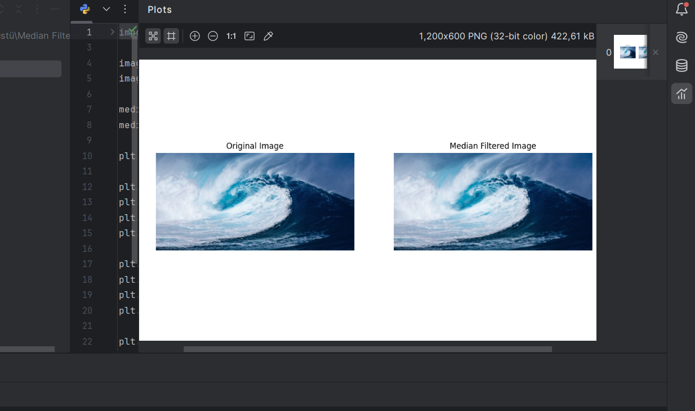
output:

Report
Objective
To apply a Median Filter to the "tsun.jpg" image to reduce noise while preserving the edges.
Methodology
- The Median Filter replaces the value of a pixel with the median of the pixel values in its neighborhood.
- A kernel of size 5×55 \times 55×5 was used in this implementation. The choice of kernel size determines the degree of noise reduction and edge preservation.
Results
- Original Image: The original "tsun.jpg" image had visible noise that affected the clarity of edges and fine details.
- Filtered Image: The Median Filter effectively reduced noise while maintaining the integrity of edges. Unlike linear filters (e.g., Gaussian), it avoided excessive blurring of the edges.
Applications
- Ideal for removing salt-and-pepper noise from images.
- Useful in preprocessing steps for computer vision applications like edge detection or segmentation.
Conclusion
The Median Filter is a robust tool for noise removal in images, especially where preserving edge details is critical. By experimenting with kernel sizes, the balance between noise reduction and detail preservation can be optimized.

